GROUP AWARD CERTIFICATE
(To receive a complimentary book for each child, you must fill this out and return it at the October Association meeting)
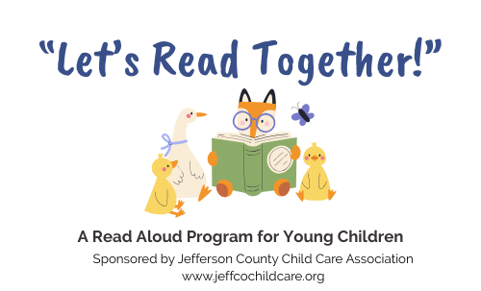

PROVIDER’S NAME

The following are the first names of the children who participated in
“LET’S READ TOGETHER!”

We read ____________ books together! Date ___________________

